**GEOGRAPHY/HISTORY:**

In history this term, we will be looking at how entertainment has changed over time, from toys and sport to music, tv and film. After half term we will explore a comparison between the UK and Uganda, looking at the similarities and differences. We will also use the Lyfta program to explore different cultures around the world.

**SCIENCE:**

In Science, we will be flying off to spaces. Exploring what it is, learning about the planets, how the earth orbits as well as different star constellations. We will also learn about how scientist have enable space travel.

After half term we will continue previous learning on materials and explore how materials can be changed and adapted. They will be testing materials and exploring their properties.

**ART AND DESIGN/ MUSIC:**

In Art, we will be looking at the work of Clarice Cliff and her Circle Tree’ ceramic plate design.

Through cross-curricular activities the children will have a chance to cook potato latkes for Chanukah.

In Music, we will be focussing on timbre and rhythmic patterns through the theme of fairy tales.

**ENGLISH:**

We will continue our phonics learning through the RWI scheme and through teaching sequences. We will be applying our phonics knowledge to both our reading and writing with a particular emphasis for all on our spelling. We will be becoming more confident with the use of our fred fingers and Y2 children will think carefully about their sound choices and when writing correct spellings. We will continue to share a book a week in guided reading, exploring the characters, story structure and expanding our vocabulary.



**Termly Overview**

**Year 1 and 2**

**Spring term 2023**

**MATHS:**

This term, Year 2 children will begin to look at multiplication and division and how we can apply these facts to problem solving. Year 1 children will learn addition and subtraction facts up to 20 using different resources to help them find these. We will be looking at money, learning the value of each coin, how we can use a variety of different coins to make different amounts and learning about change. 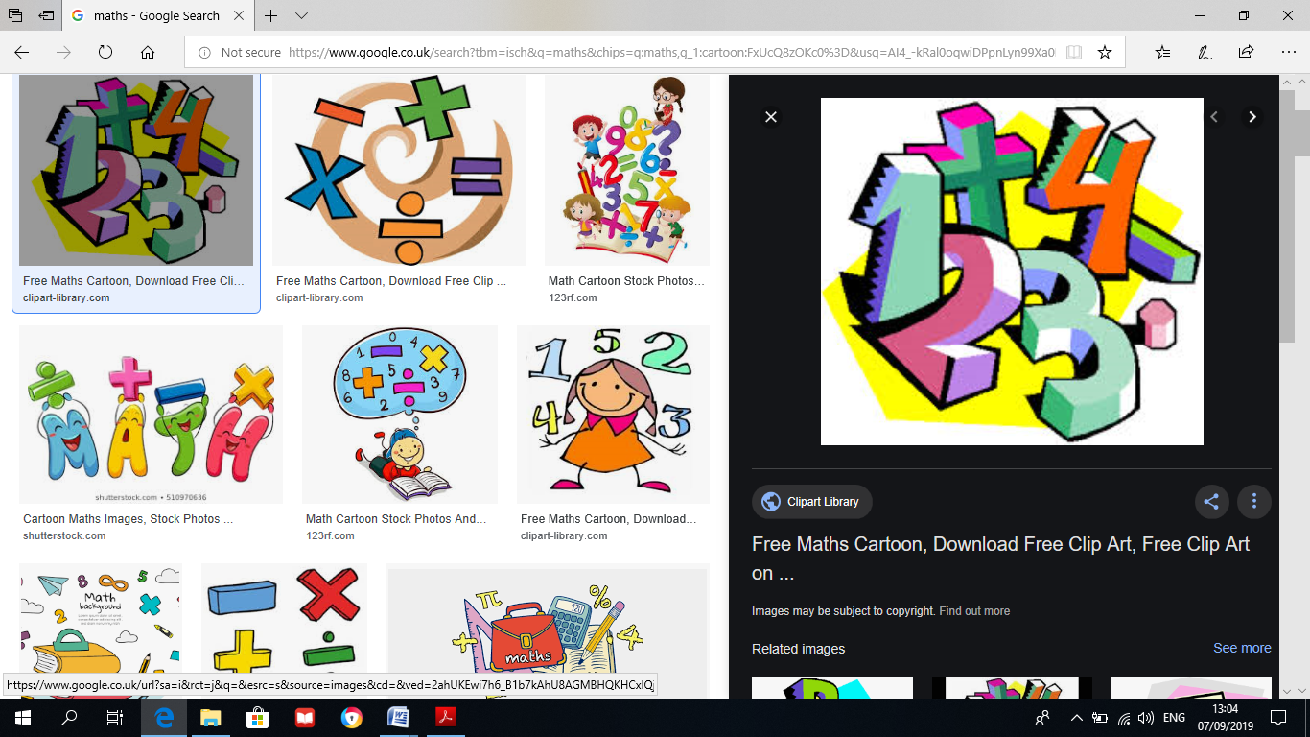

**Live, Love, Learn.**

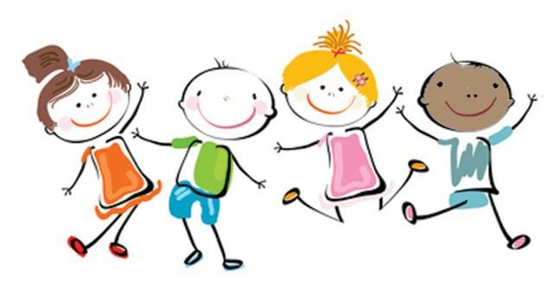

**PHYSICAL/OUTDOOR EDUCATION:**

In PE we will be following the Real PE programme with support from Mr Pugh. We will continue learning a variety of different ball skills and will also be thinking about different ways we can move our body.



**Computing:**In computing, we will spend time programming animations on Scratch Jr before moving on to regrouping pictograms as we revisit data and information.

**PSHE:**

In PSHE we will be thinking how we can stay safe and what we should say and who we should tell if we don’t feel safe.

**RE:**

In RE, we will be continuing the topic of Judaism focusing on the celebration of Chanukah through re-enacting stories, looking into celebrations and the food they eat.

In the second half term, we will be focusing on ‘Why does Easter matter to Christians?’.

Please talk to your child at home about their learning in school and encourage them to read at home. Do ask if you have any queries about any of your child’s learning.

Many thanks for your ongoing support,

Miss Whiteley and Miss Balsdon