Class 1 HOMEWORK Spring 2023  All children are expected to complete the following each week:  - Phonics/spelling word practice (Year 1 and Year 2 only) – this can be handwriting the words or by creating a sentence using the word. Children will have lists of tricky (red) words in their reading records. QR codes will also be sent home with videos that children can watch for additional phonics practise. This is for ALL children.  - Reading aloud to an adult at home – at least 5 times a week. Every day is best. Please record reading in the Reading Record. Rewards will be given for 5 home reads!  - One project homework task per term. | Project 1 – History
 | 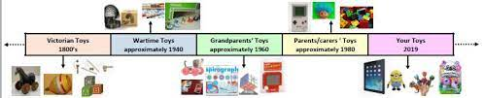 | Talk to your parents about the toys you have to play with, and then toys that they had to play with when they were your age. What toys did you Grandparents play with or even your Great Grandparents. Draw a picture of each toy and put it on a timeline with a bit of information about it.
 | Project 2 – Science
 |  | This term we are learning about Space. Can you design and make your own rocket? Does it have an special features?
Homework projects will be set termly to help consolidate learning taking place in school. Project homework tasks are for every child to engage in and encourage creativity in learning. Choose one project to complete this half term. If you want to do more, you can! Learning at home helps to accelerate your child’s progress.

Please choose 1 homework project to complete this term (as well as your weekly phonics and reading practise)

We will invite parents into school in the second half of term to see the homework and celebrate home learning.

Thank you for the ongoing support with your child’s home learning.

Miss Whiteley and Miss Balsdon
 | Project 3 – RE
 | 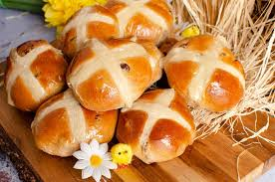 | Have a go at making hot cross buns (there is a simple recipe here Easy hot cross buns recipe for kids | Cooking with my kids)  Take a picture of your hot cross buns and write about how you made them. Did you like tasting them?  Can you find out what the cross on the top and the fruit and spices in the hot cross bun symbolise?

