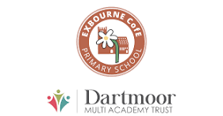
Exbourne: Encouraging Excellence
8th March 2024

'Let us spur one another to acts of love and good deeds.' Hebrews 10:24

Dear Exbourne Families,

I am delighted to share our SIAMS report with you. This was the inspection we had at the end of last term where our visitors observed lessons, worship and play times, looked at children’s books, analysed our data and met with pupils, parents, trustees, and staff.

The purpose of a SIAMS inspection is: to provide an evaluation of the impact of the school's distinctively Christian vision to meet the requirements of section 48 of the Education Act 2005 for schools which have a religious character.
SIAMS Inspections | The Church of England

The report speaks of the journey we are on together, what we have achieved and what we need to do next. Thank you very much to all of you for your continuing support of our fabulous school where we are ‘spurring each other on to love and good deeds.’

Please read the report here SIAMS Report February 2024

Wishing you all great weekend,

With very best wishes

Tara Penny
Principal

