**GEOGRAPHY/HISTORY:**

In history this term, we will be learning about Ancient Greece, including Ancient Greek beliefs, inventions and way of life.

In geography, we are learning about water, weather and climate. We will learn what causes different types of weather as well as how the water cycle works. We will also look at how our climate is changing due to global warming.

**SCIENCE:**

In Science this term we will be learning about space, including how the Earth rotates around the Sun to cause the seasons and how the planets in our Solar System interact. We will also look at the Space Race and important historical figures who contributed to it.

**ART AND DESIGN/ DT/ MUSIC:**

In Art we are making willow pattern plates. The children are focusing on fine brush strokes and using saturation to create depth. They will link this to their historical knowledge by retelling the story of Odysseus on their plate.

In DT we are looking at designing structures using nets. Children will use their knowledge of 3D shapes to build a scale model of a Greek temple.

In music, we are practicing listening to music from different cultures and spotting the differences.

**ENGLISH:**

We are studying playscripts, with the aim of creating a play that retells the Ancient Greek myth of Odysseus and the Cyclops. After half term we will be focusing on writing instructions and on using subordinating conjunctions to join parts of a sentence.

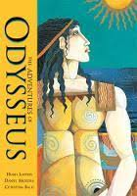

**Class 2**

**Termly Overview**

**Year 3 and 4**

**Spring term 2023**

**MATHS:**

This term, we are finishing multiplication and division and starting to look at length, perimeter and measuring distances. We will then study fractions and the children will use their prior division knowledge to help them split wholes into equal parts.

**Live, Love, Learn.**

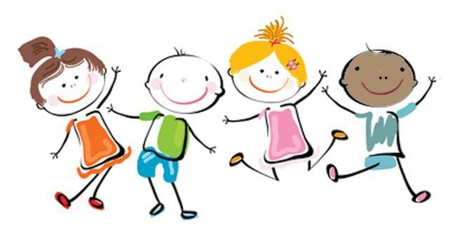

**PHYSICAL/OUTDOOR EDUCATION:**

In PE we will be focusing on balance, using different levels to achieve different types of partner balance. We will work on core strength and using our arms to support for more difficult balances.

**Computing:**In computing, we are using LOGO to create repeating patterns. Children will learn how to code different shapes and what code is needed to repeat them.

**PSHE:**

In PSHE we will learn about dangers, risks and hazards and how to keep ourselves safe. Children will learn how to assess risks as well as who to go to when they feel unsafe.

**RE:**

In RE we are looking at Islamic festivals and why they are important to Muslims. We will compare these to the Jewish festivals we have learnt about in the autumn term.

Please talk to your child at home about their learning in school and encourage them to read at home. Do ask if you have any queries about any of your child’s learning.

Many thanks for your ongoing support,

Miss Weber