**Expressive Art and Design:**

In Art, we will be mixing primary colours to make secondary colours for paintings based on the work of Clarice Cliff and her Circle Tree’ ceramic plate.

Through cross-curricular activities the children will have a chance to cook potato latkes for Chanukah.

In Music, we will be focussing on timbre and rhythmic patterns through the theme of fairy tales.

**Communication and Language:**

This term we will be looking at lots of different stories. We will remember key points within a story and be able to identify the characters and events within the story as well as answer questions about the text. We also be able to discuss different stories as a group and ask how and why questions. We will learn different songs, poems and rhymes and perform them.

**Personal, Social, Emotional Development:**

We will be thinking about how we can stay safe; this will include thinking about what is safe to eat, keep ourselves safe both indoors and outdoors, online and how other people help to keep us safe. We also be learning about how we can look after special people, including our friends and family, how we can be help both at home and in the classroom and how we can care for the world around us.



**Termly Overview**

**Early Years Foundation Stage**

**Spring term 2023**

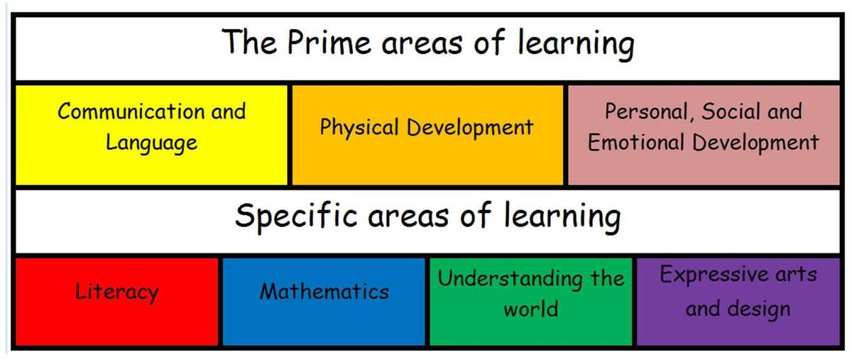

**Mathematics:**

In Maths we will be understanding what 0 means and comparing numbers to 5. We will be looking at combining groups to make up to 10 using this to find out number bonds to 10. We will also be exploring length and height and weight and capacity as well as 3D shapes.



**Literacy:**

We will develop our reading and writing further using the Read Write Inc phonics programme. We will be able to locate the title in books and read with one to one correspondence. We will be able to segment and blend simple words and read with increasing confidence. We will begin to write different lists, labels and captions in our play.

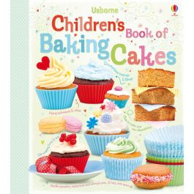

**Physical Development:**

In PE, we will be continuing our sessions using the real PE scheme. Miss Whiteley will be working alongside Mr Pugh (a specialist PE teacher) to deliver some of these sessions. We will be taking part in lots of fine motor activities to further strength our fingers including threading, cutting, pegboards and dough disco. 

**Understanding the World:**

We will be exploring different toys and entertainment, thinking about how these things have changed over the years. We will also be exploring space and the planets. We will be recognising that people have different beliefs. We will be able to describe the special event of Easter and talk about the events that led up to Jesus rising again.

Please talk to your child at home about their learning in school and continue to read at home. Do ask if you have any queries about any of your child’s learning.

Many thanks for your ongoing support,

Miss Whiteley and Miss Balsdon