Class 3 HOMEWORK Spring 2023  All children are expected to complete the following each week:  - Spelling practice – this can be handwriting the words, doing look, say, cover, write and check or by creating a sentence using the word. Children will have a list of 6-8 words. Children will be tested on their words each Friday and set a new list each week.  - Reading for at least 10 minutes a day. This can be a fiction book, non- fiction, a magazine, or a newspaper. Reading a variety of material will be very beneficial now, and in the future, to support their learning.  - One project homework task per term. | Project 1 – History
 | 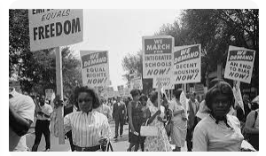 | Research one of these key figures from the American Civil Rights Movement, in the 1950s, and produce a fact file (1 side of A4) along with labelled pictures from the internet or hand drawn ones.  - Oliver Brown  - Rosa Parks  - Martin Luther King  - Mary White Ovington
 | Project 2 – Art
 | 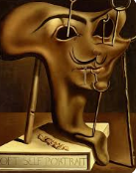  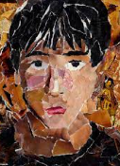 | This term we are learning about Picasso, through portraits. Can you create a self-portrait in a new and original way using any medium. You may wish to use torn up magazine pieces, newspaper pieces, paint, clay or any other art or recyclable materials you have at home.
Homework projects will be set termly to help consolidate learning taking place in school. Project homework tasks are for every child to engage in and encourage creativity in learning. Choose one project to complete this half term. If you want to do more, you can! Learning at home helps to accelerate your child’s progress.

Please choose 1 homework project to complete this term (as well as your weekly spellings and reading practise).

We will invite parents into school in the second half of term to see the homework and celebrate home learning.

Thank you for the ongoing support with your child’s home learning.

Mrs Willis and Mrs Bonnett
 | Project 3 – RE
 | 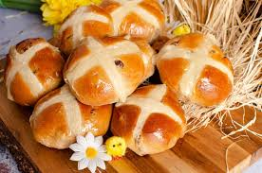 | Have a go at making hot cross buns (there is a simple recipe here Easy hot cross buns recipe for kids | Cooking with my kids)  Take a picture of your hot cross buns and write about how you made them. Did you like tasting them?  Can you find out what the cross on the top and the fruit and spices in the hot cross bun symbolise?

