Class 1 HOMEWORK Spring 2023  All children are expected to complete the following each week:  - Spelling practice. Each child is expected to write their spellings, check and correct and then use them in a sentence.  - Reading aloud to an adult at home – at least 5 times a week. Every day is best. Please record reading in the Reading Record. Children receive a reward for a certain number of recorded reads (starting at 25 recorded reads) so please help them achieve this!  - Times tables practice every week. There are a number of websites children can use to practice their times tables. Times tables grid - Timestables.co.uk is a good one.  - One homework project of their choice. | Project 1 – History
 | 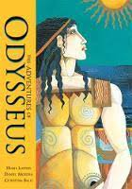 | Research and retell an Ancient Greek myth of your choice. You could present your retelling in a few different ways. You might record a video of you re-enacting it or perhaps draw a comic strip of the story.
 | Project 2 – Science
 |  | This term we are learning about Space. Can you make a model of the Solar System. Which planets will you need to include?
Homework projects will be set termly to help consolidate learning taking place in school. Project homework tasks are for every child to engage in and encourage creativity in learning. Choose one project to complete this half term. If you want to do more, you can! Learning at home helps to accelerate your child’s progress.

Please choose 1 homework project to complete this term (as well as your weekly spellings, times tables and reading practise)

We will invite parents into school in the second half of term to see the homework and celebrate home learning.

Thank you for the ongoing support with your child’s home learning.

Miss Weber
 | Project 3 – PSHE
 | 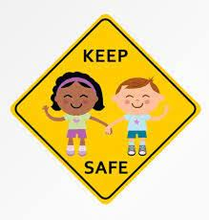 | Our PSHE topic this term is ‘Keeping Safe’. Design a poster or presentation that explains how to keep safe in different situations. For example, when crossing the road.

