Exbourne: Encouraging Excellence
School Newsletter
18th March 2024

'Let us spur one another to acts of love and good deeds.' Hebrews 10:24

Dear Exbourne Families and Friends,

Staff News
Mrs Bonnett is away for personal medical reasons. Thank you for your kind wishes, I have passed these on to her and I will let you know when she is returning to work. We welcome Mrs Hislop, who has been getting to know Dove Class, and will continue to teach the class in Mrs Bonnett’s absence.

Tin Can Collection
This week is the last week of our tin can collection. Please bring along your cans for this worthy cause. We need your cola, soda / pop, beer and cocktail cans! Please bring them to school on Wednesday where there will be a box at the gate. The cans will be recycled, and the money obtained will be given to the charity Families in Greif.

Help for grieving children & families | Families in Grief

Attendance
Well done to Olive class last week – 100%
This week, Dove almost made the goal of 100%

Olive Class 100% last week, 89% this week
Dove Class 97% last week, 98% this week

Easter Service
Please join us on Wednesday 27th March at 2.30 for our Easter Service. We will be in the church followed by a bake sale to raise funds for the school. Do invite friends and family!

Exbourne 40 Acts of Kindness 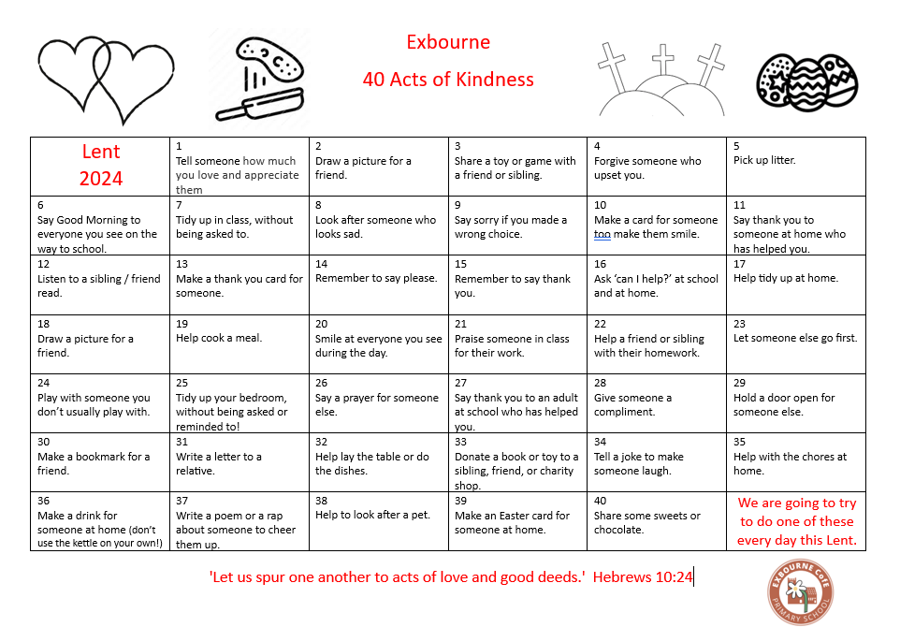

Today is day 27 of our Lent 40 Acts of Kindness I’d love to hear lots of children, and adults, saying thank you to someone who has helped them.

Exbourne: Encouraging Excellence
We are very proud of the work we are doing and will continue to do to enable our school community to flourish. Have you read our SIAMS report? The report speaks of the journey we are on together, what we have achieved and what we need to do next. Thank you very much to all of you for your continuing support of our fabulous school where we are ‘spurring each other on to love and good deeds.’ Please read the report here SIAMS Report February 2024
siams-report-exbourne-vc-primary-145339-050224.pdf

Please see our regular news updates on Facebook at Exbourne Church of England Primary School

Wishing our Olive Class a wonderful trip to Exeter tomorrow, I am looking forward to hearing all about it!

With very best wishes
Tara Penny
Principal

