Newsletter
Exbourne Church of England Primary School – Live, love, learn
15th November 2019
A time of charity
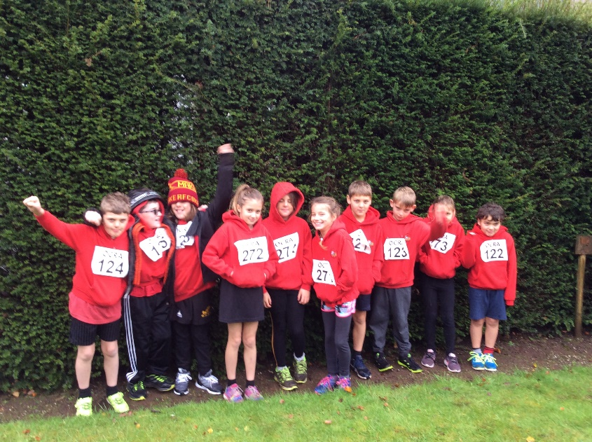
As a Church of England School, charity is at the heart of our ethos. We encourage our children to think about others less fortunate and how we may support them, how to ‘Love thy neighbour’. Recently the school has participated in charity fundraising for Operation Christmas Child, The Poppy Appeal, Team GB’s Athlete Fund as well as our own PFA. The good work these charities do enables children and adults around the world have a brighter future and access some of the opportunities we are so fortunate to have. Thank you for your continued support of our charity work – it is very much appreciated.
Cross country runners at Castle Drogo

Futsal tournament – Okehampton College
A team of children represented the school at the recent ‘Futsal’ tournament in Okehampton. The team played really well and progressed with each match. Thank you to the staff and parents for support the event.

Phonics workshop
Thank you to those parents who took part in our recent phonics workshop or who engaged with the materials available on our website – including a video of a phonics session. We are actively seeking to engage with our parents for the benefit of our pupils. Our next workshops will be focused on Writing and will happen in the week beginning the 6th January.

Cross country and Castle Drogo
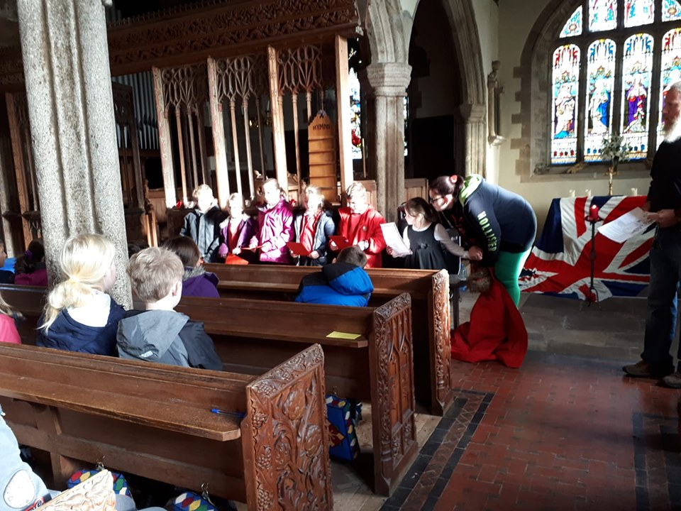
Yesterday a team of children raced at Castle Drogo in their annual cross country event. Despite the cold and rain the children were determined and did extremely well. Again, thank you to the parents and staff that made the event possible.

Operation Christmas Child
Well done the School Council who organised the Operation Christmas Child appeal in school. We have sent 8 shoe boxes to children around the world who otherwise may not know the joys of Christmas. The children’s cake sale was successful and raised £30 to help post those boxes.

Team GB athlete visit and sponsorship
On Friday 29th November we will be visited by Ezekiel Ewulo – Team GB long jumper – for a motivational speech and sponsored circuit training. This is a fantastic opportunity for children to be inspired by a real athlete!
Please could the sponsor forms and money for our Team GB athelete visit, Ezekiel Ewulo, be returned to school by Friday 22nd November. Remember – the money covers admin costs for the visit and any extra is shared between the school and Team GB’s ‘Athlete Fund’ that supports up and coming young athletes.
Also, there are rewards for raising set amounts: Raising £5 will earn you a signed postcard, £15 a signed A4 poster, £35+ will earn you a signed ‘selfie’ with Ezekiel in a special presentation wallet.
More information about the charity can be found at the ‘Sports for Champions’ website.

Remembrance service
Children supported Revd Leigh in delivering a poignant remembrance service on Monday 11th at 11am. A moments silence was observed which allowed the children to reflect upon the day and think about how lucky we are to live in a free and open society.

Parent survey - Autumn 2019
As a school we are always keen to hear how parents feel their child is doing at our school. Please spare 2 minutes to complete the parental survey - 1 per child in your family. This will help us to understand where we are doing well and where we can improve. Thank you for your co-operation.
https://forms.office.com/Pages/ResponsePage.aspx?id=kG0HO7J4vUqeBcIPJiicRnIQax2A75VKtdlTAzqF25lUQ1JUTk9BREtIWVQ4S1I5VkhDRktDNVBIUi4u

Parents’ forum – 19th November
Please join us for a parents’ forum on Tuesday 19th of November at 9am. The focus will be January staffing, Writing and any other discussion topics brought forward by parents. As you know, our parents’ forum rotate days and times throughout the year to give as many people the opportunity to attend as possible. Please could you let Mrs Chapman know, or use the poll on the Facebook group, if you are able to attend this week.

Recycling assembly
On Thursday 21st November we will be visted by West Devon’s recycling team who are going to speak to the children about the changes to recycling collections and the importance of recycling. One of the key questions related to our ethos is ‘How do we live our lives to look after the environment?’.

Climbing and bouldering event – 22nd November
A team of children has been selected to attend Milton Abbot climbing barn on Friday 22nd November for a climbing and bouldering event. This annual event gives children an opportunity to experience a different sport that they may have not tried before – all part of our curriculum offer.

Diary
There has been a lot of illness over the last two weeks- rest up over the weekend so we are bright and fresh for Monday!
Other activities at the Devon School Games
November
- 18th – Worship with Rev. Leigh – The lost son
- 19th – Parents’ forum – 9am
- 21st – Assembly from West Devon Recycling – new recycling collections. Parents/carers welcome
- 22nd – Climbing and bouldering
- 29th – Visit from Team GB athlete Ezekiel Ewulo, sponsored circuits and motivational assembly.
December
- 2nd – Worship with Rev. Leigh – Advent
- 3rd – Last KS1 swimming session – Parents welcome
- 10th – Carol singing at Hatherleigh residential care home
- 12th – Carol singing at Okehampton Library
- 12th – Christmas play, led by Class One – afternoon and evening performances
- 13th – Class One trip to Castle Drogo – Christmas
Stars of the week!
Class One Star: Isabella – for so hard on her spelling.
Class Two Star: Kelsey-for trying so hard with a smile! Loving work.
Class Three Star: Phoebe – for methodically planning her mosaic design and finishing it with precision.

- 13th – Christmas jumper day
- 13th – MAT school council - Okehampton
- 17th – Trip to Exeter Northcott Panto – Beauty and the Beast
- 18th – Christingles with Rev. Leigh
- 18th – Christmas lunch
- 19th – Carol singing at Waitrose, Okehampton – 9.30am
- 19th – Carol service – St Mary’s Church – 2.30pm
- 20th – Last day of term

Mr Hill – head@exbourne-primary.devon.sch.uk

